Project Title : QUIZHUB

- Admin-side

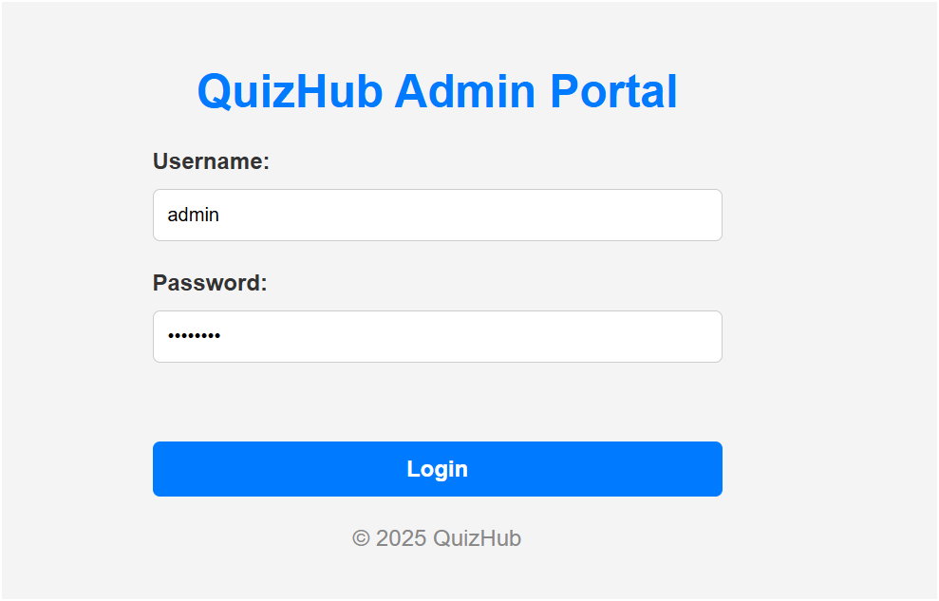

fig. 1.1 Admin LOGIN PAGE

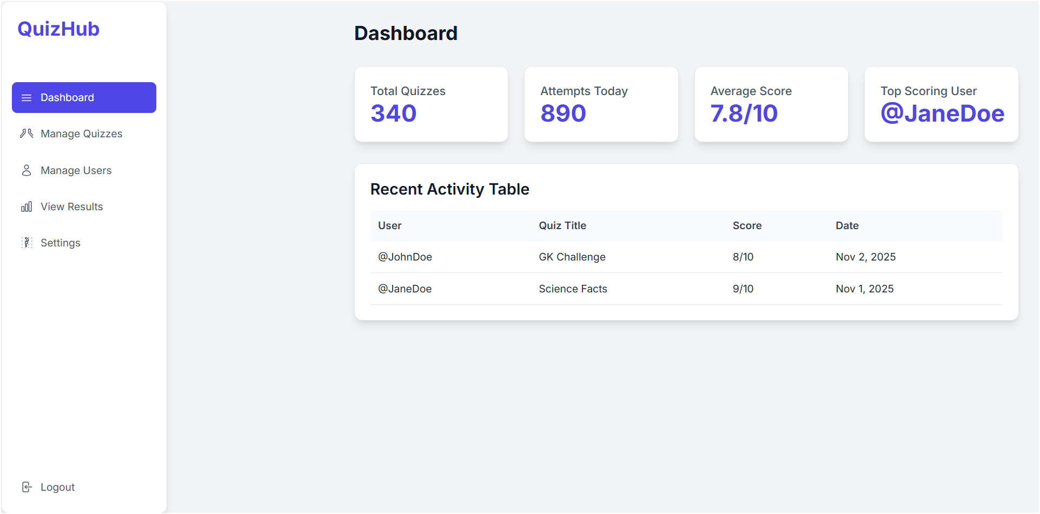

fig. 1.2 Admin Dashboard screen

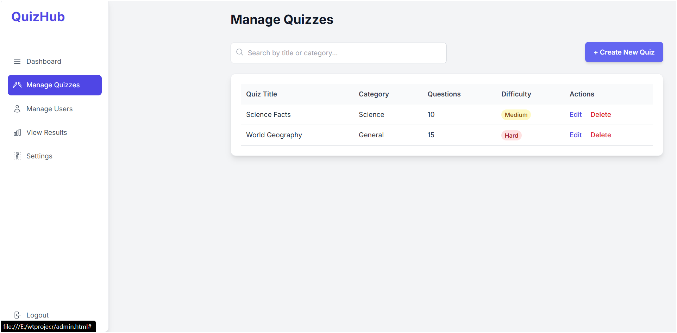

fig. 1.3 QUIZ MANAGER

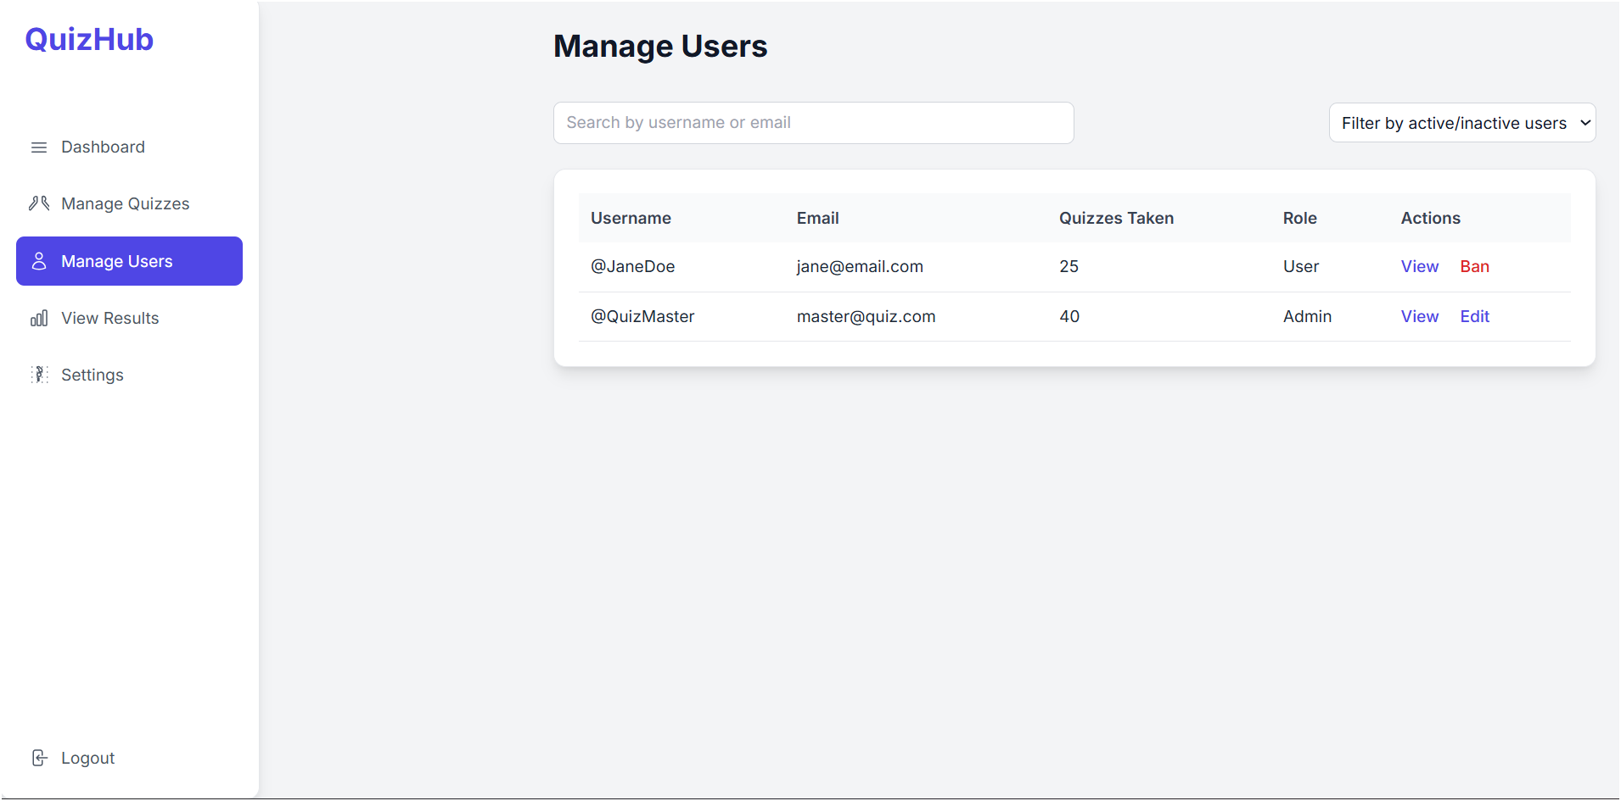

fig. 1.4 USER MANAGER

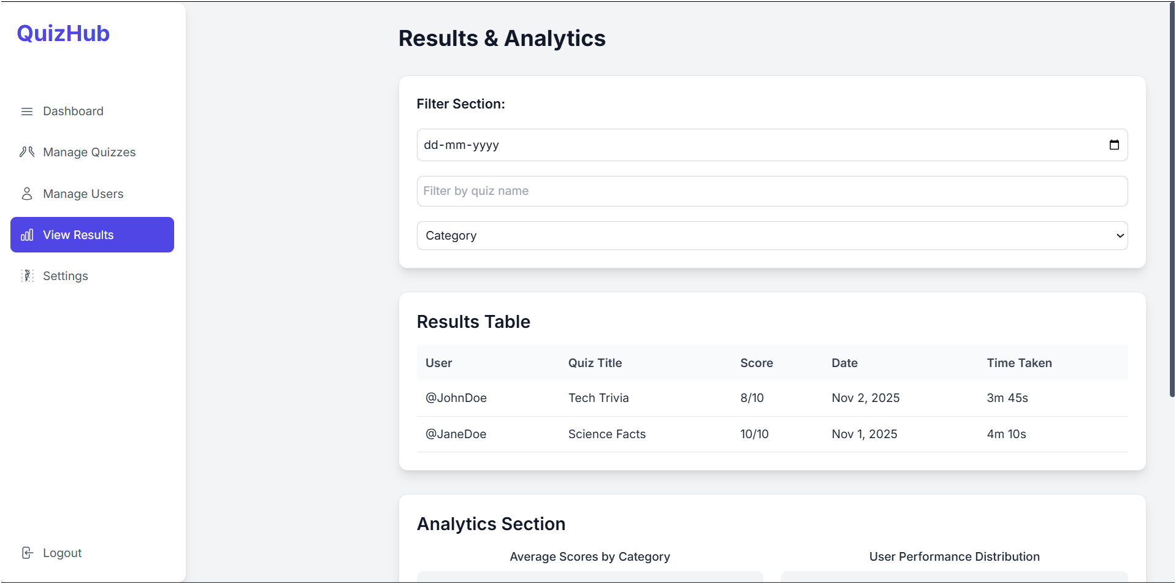

fig. 1.5 QUIZ ANALYTICS

